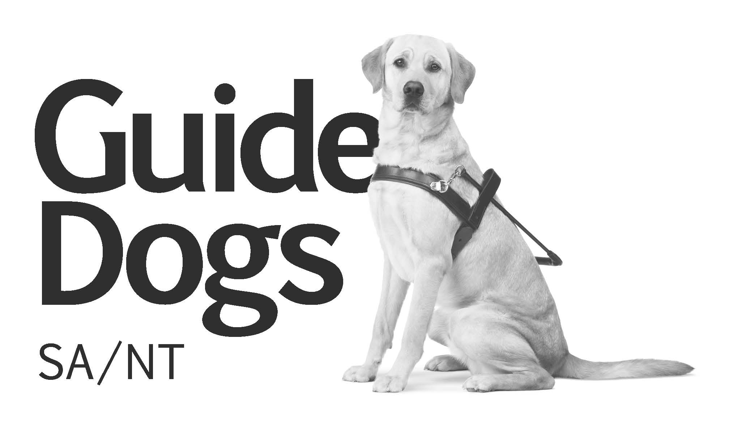Form D168

VS Referral Form v4.0

|  |  |  |  |  |  |  |
| --- | --- | --- | --- | --- | --- | --- |
| Office Use Only | | | | | | |
| Referral Date: |  | Type: | New  Re | | Consent: | Yes  No |
| Form completed by (if different to referral source): | | | |  | | |

|  |  |  |  |  |  |  |  |  |  |  |  |  |  |  |  |  |  |  |  |  |  |  |  |  |  |  |  |  |  |
| --- | --- | --- | --- | --- | --- | --- | --- | --- | --- | --- | --- | --- | --- | --- | --- | --- | --- | --- | --- | --- | --- | --- | --- | --- | --- | --- | --- | --- | --- |
| Personal Details | | | | | | | | | | | | | | | | | | | | | | | | | | | | | |
| Surname: | |  | | | | | | | | | | | | Other names: | | | | | | | |  | | | | | | | |
|  | | | | | | | | | | | | | | | | | | | | | | | | | | | | | |
| Male  Female | | | | | | | | | | | | | | | | | | | | | | | | | | | | | |
|  | | | | | | | | | | | | | | | | | | | | | | | | | | | | | |
| Address: | |  | | | | | | | | | | | | | | | | | | | | | | | | | | | |
|  | | | | | | | | | | | | | | | | | | | | | | | | | | | | | |
|  | | | | | | | | | | | | | | Postcode: | | | | |  | | | | | | | | | | |
|  | | | | | | | | | | | | | | | | | | | | | | | | | | | | | |
| Phone Number: | | | |  | | | | | | | | | | Mobile: | | | | |  | | | | | | | | | | |
|  | | | | | | | | | | | | | | | | | | | | | | | | | | | | | |
| Work Number: | | | |  | | | | | | | | | | Email: | | | | |  | | | | | | | | | | |
|  | | | | | | | | | | | | | | | | | | | | | | | | | | | | | |
| Date of Birth: | | | |  | | | | | | | | | | Country of Birth: | | | | | | | | | |  | | | | | |
|  | | | | | | | | | | | | | | | | | | | | | | | | | | | | | |
| Language preferred: | | | | | |  | | | | | | | | Interpreter required? | | | | | | | | | | | Yes  No | | | | |
|  | | | | | | | | | | | | | | | | | | | | | | | | | | | | | |
| Is the person of Aboriginal or Torres Strait Islander Origin? | | | | | | | | | No  Yes, Aboriginal  Yes, Torres Strait Islander  Yes, both Aboriginal and Torres Strait Islander | | | | | | | | | | | | | | | | | | | | |
|  | | | | | | | | | | | | | | | | | | | | | | | | | | | | | |
| Communication needs: | | | | | | | | Large Print  Braille  Oral  Auslan  Email  CD | | | | | | | | | | | | | | | | | | | | | |
|  | | | | | | | | | | | | | | | | | | | | | | | | | | | | | |
| Employment status: | | | | | | |  | | | | | | | | | | | | | | | | | | | | | | |
|  | | | | | | | | | | | | | | | | | | | | | | | | | | | | | |
| Pension/benefit (type): | | | | | | |  | | | | | | | | | | | | DVA Card: | | | | | | Yes  No | | | | |
|  | | | | | | | | | | | | | | | | | | | | | | | | | | | | | |
| Work cover/compensation claim/ other: | | | | | | | | | | | |  | | | | | | | | | | | | | | | | | |
|  | | | | | | | | | | | | | | | | | | | | | | | | | | | | | |
| Specialist Information | | | | | | | | | | | | | | | | | | | | | | | | | | | | | |
| GP: | |  | | | | | | | | | | | | | | | Surgery: | | | |  | | | | | | | | |
|  | | | | | | | | | | | | | | | | | | | | | | | | | | | | | |
| Address: | |  | | | | | | | | | | | | | | | | | | | | | | | | | | | |
|  | | | | | | | | | | | | | | | | | | | | | | | | | | | | | |
| Phone number: | | | |  | | | | | | | | | | | | | Fax: | | | |  | | | | | | | | |
|  | | | | | | | | | | | | | | | | | | | | | | | | | | | | | |
| Ophthalmologist: | | | |  | | | | | | | | | | | | | Phone: | | | |  | | | | | | | | |
|  | | | | | | | | | | | | | | | | | | | | | | | | | | | | | |
| Optometrist: | | | |  | | | | | | | | | | | | | Phone: | | | |  | | | | | | | | |
| Next of Kin | | | | | | | | | | | | | | | | | | | | | | | | | | | | | |
| Name: | | |  | | | | | | | | | | | | Relationship: | | | | | | | |  | | | | | | |
|  | | | | | | | | | | | | | | | | | | | | | | | | | | | | | |
| Phone Number: | | |  | | | | | | | | | | | | Mobile: | | | | | | | |  | | | | | | |
|  | | | | | | | | | | | | | | | | | | | | | | | | | | | | | |
| Alternative /Appointment Contact: | | | | | | | | | |  | | | | | | | | | | | | | | | | | | | |
|  | | | | | | | | | | | | | | | | | | | | | | | | | | | | | |
| For appointment please contact: | | | | | | | | | | Client  Next of kin  Other | | | | | | | | | | | | | | | |  | | | |
| Referral Details | | | | | | | | | | | | | | | | | | | | | | | | | | | | | |
| Reason for referral: | | | | | Orientation & Mobility Low Vision Assessment Falls Prevention | | | | | | | | | | | Neurological Vision Service Occupational Therapy Physiotherapy | | | | | | | | | | | | Orthoptics Education NDIS | |
|  | | | | | | | | | | | | | | | | | | | | | | | | | | | | | |
| Reason for Vision Assessment/Intervention: | | | | | | | | | | | | |  | | | | | | | | | | | | | | | | |
|  | | | | | | | | | | | | | | | | | | | | | | | | | | | | | |
| Eye condition and cause of vision loss: | | | | | | | | | | |  | | | | | | | | | | | | | | | | | | |
|  | | | | | | | | | | | | | | | | | | | | | | | | | | | | |
| Date of incident: | | | | |  | | | | | | | | | | | | | | | | | | | | | | | | |
|  | | | | | | | | | | | | | | | | | | | | | | | | | | | | | |
| Details of recent eye assessment (attach if available): | | | | | | | | | | | | | | | | | |  | | | | | | | | | | | |
|  | | | | | | | | | | | | | | | | | | | | | | | | | | | | | |
| Other details: | | | | |  | | | | | | | | | | | | | | | | | | | | | | | | |
|  | | | | | | | | | | | | | | | |  | | | | | | | | | | | | | |
| Is the client distressed due to changes in vision? | | | | | | | | | | | | | | | | | | | | | | | | | | | Yes  No | | |
|  | | | | | | | | | | | | | | | | | | | | | | | | | | | | | |
| Has the client had a recent fall/history of falls due to vision? | | | | | | | | | | | | | | | | | | | | | | | | | | | Yes  No | | |
|  | | | | | | | | | | | | | | | | | | | | | | | | | | | | | |
| Is the client able to attend GDA SA/NT clinic at 251 Morphett St Adelaide? | | | | | | | | | | | | | | | | | | | | | | | | | | | Yes  No | | |
|  | | | | | | | | | | | | | | | | | | | | | | | | | | | | | |
| Medical history: | | | | |  | | | | | | | | | | | | | | | | | | | | | | | | |
| Referral Source | | | | | | | | | | | | | | | | | | | | | | | | | | | | | |
| Name: |  | | | | | | | | | | | | | | | Position: | | | |  | | | | | | | | | |
|  | | | | | | | | | | | | | | | | | | | | | | | | | | | | | |
| Organisation: | | | | |  | | | | | | | | | | | | | | | | | | | | | | | | |
|  | | | | | | | | | | | | | | | | | | | | | | | | | | | | | |
| Address: |  | | | | | | | | | | | | | | | | | | | | | | | | | | | | |
|  | | | | | | | | | | | | | | | | | | | | | | | | | | | | | |
| Phone: |  | | | | | | | | | | | | | | | Fax: | | | |  | | | | | | | | | |
|  | | | | | | | | | | | | | | | | | | | | | | | | | | | | | |
| Email: |  | | | | | | | | | | | | | | | | | | | | | | | | | | | | |
|  | | | | | | | | | | | | | | | | | | | | | | | | | | | | | |

|  |  |
| --- | --- |
| Preferred Contact: | Email  Phone  Fax |

|  |  |  |  |  |  |  |  |  |  |  |  |  |  |
| --- | --- | --- | --- | --- | --- | --- | --- | --- | --- | --- | --- | --- | --- |
| Mobility | | | | | | | | | | | | | |
| Mobility Status | | | | Independent | Standby | | | Assist | | | | | Not mobile |
| Current Mobility Aid: | | | | Wheelchair Long cane | Frame ID cane | | | Walking stick Guide Dog | | | | | Motorised scooter No aids |
|  | | | | | | | | | | | | | |
| Indoors: |  | | | | | | Outdoors: | |  | | | | |
|  | | | | | | | | | | | | | |
| Driver’s License: | | | Yes  No | | | | Suspended | | | | Yes  No | | |
|  | | | | | | | | | | | | | |
| Alert Details | | | | | | | | | | | | | |
| Is the client performing tasks that could present a safety risk? | | | | | | | | | | | Yes  No | | |
|  | | | | | | | | | | | | | |
| Behavioural considerations? | | | | | | | | | | | Yes  No | | |
|  | | | | | | | | | | | | | |
| Environmental considerations? | | | | | | | | | | | Yes  No | | |
|  | | | | | | | | | | | | | |
| Details: | |  | | | | | | | | | | | |
| Inpatient Details (if applicable): | | | | | | | | | | | | | |
| Hospital: | | |  | | | Acute /Rehabilitation | | | | | |  | |
|  | | | | | | | | | | | | | |
| Ward: | | |  | | | Bed number: | | | | | |  | |
|  | | |  | | |  | | | | | |  | |
| Admission Date: | | |  | | | Estimated date of discharge: | | | | | |  | |
|  | | | | | | | | | | | | | |
| Is the client being discharged home alone? | | | | | | | | | | | Yes  No | | |
| Is vision impacting on ability to engage in rehab program? | | | | | | | | | | | Yes  No | | |
| Would vision assessment/intervention affect the discharge outcome? | | | | | | | | | | | Yes  No | | |
| Is the client returning to work/study? | | | | | | | | | | | Yes  No | | |
| Will the client be providing care for someone else after discharge? | | | | | | | | | | | Yes  No | | |
| Is the client being discharged to a regional area? | | | | | | | | | | | Yes  No | | |
|  | | | | | | | | | | | | | |
| List any other services involved and contact details (if applicable): | | | | | | | | | |  | | | |
|  | | | | | | | | | | | | | |
| Comments: | | |  | | | | | | | | | | |

|  |  |  |  |  |  |  |  |  |  |  |  |  |  |  |  |  |  |  |  |  |  |  |  |  |  |  |  |  |  |  |  |  |  |  |  |  |  |  |  |  |  |  |  |  |  |  |  |
| --- | --- | --- | --- | --- | --- | --- | --- | --- | --- | --- | --- | --- | --- | --- | --- | --- | --- | --- | --- | --- | --- | --- | --- | --- | --- | --- | --- | --- | --- | --- | --- | --- | --- | --- | --- | --- | --- | --- | --- | --- | --- | --- | --- | --- | --- | --- | --- |
| National Disability Insurance Scheme (NDIS) – If Applicable   |  |  |  | | --- | --- | --- | | Guide Dogs SA/NT Client Status: | New Client | Existing Client | | NDIS Plan Status: | No current plan (client seeking pre-planned support) | | |  | Plan in place (client wishes to commence NDIS services – complete details below) | |   NDIS services requested (include allocated hours/funding, if known):   |  | | --- | |  |  |  |  | | --- | --- | | NDIS Reference Number: |  |  |  |  |  | | --- | --- | --- | | Plan Funds: | Self-Managed | Agency (MyPlace portal) managed |  |  |  |  |  | | --- | --- | --- | --- | |  | Plan Manager Provider | Combination | Unknown |  |  |  |  |  |  |  | | --- | --- | --- | --- | --- | --- | | Copy of NDIS Plan | Provided? | Yes  No | Requested? | Yes  No | Details: |  Appendix One – Home Visiting Risk Assessment  |  |  | | --- | --- | | Does the client have any hesitations/concerns in allowing this service into their home? | Yes  No | | Is there any potential for or a history of violence or aggression in the household? | Yes  No | | Is there anything in regard to the client/others/household that might be a potential risk to anyone visiting the home? | Yes  No | | Are any other people expected to be present at the time of the visit/service? | Yes  No | | Are there any special directions needed to get to the clients home? | Yes  No | | Are the premises easily accessible and visible from the street? | Yes  No | | Is someone able to readily open the door? | Yes  No | | Are there any domestic animals on the premises? | Yes  No | | If so, are they able to be restrained/removed for the visit? | Yes  No | | Does the client or others in the household smoke? | Yes  No | | If so are they able to not smoke during the visit? | Yes  No | |
| If the answer was yes or unknown to any of the questions above please provide further explanation: |
|  |

|  |
| --- |
| Please send/fax this form to:  Vision Services  Guide Dogs SA/NT  251 Morphett Street  Adelaide SA 5000  Fax: (08) 8203 8332  [clients@guidedogs.org.au](mailto:clients@guidedogs.org.au)  for enquiries please call: (08) 8203 8333 |